
INFORMATION SECURITY LAB PROJECT
Documentation: File Locker System

May 17, 2026
mUHAMMAD.bILAL (FA24-bSE-023)
MUHAMMAD AFNAN (FA24-BSE-008)

Project Overview
This project is a File Locker System built in Python. It allows a user to:
- Encrypt files (text, PDF, DOCX, or any binary file) using the Vigenère Cipher.
- Decrypt files back to their original form.
- Protect access with a SHA-256 hashed password.
- Handle both text files (readable characters) and binary files (PDF, DOCX, images).
The locker uses three password stages:
- Set password (when starting program).
- Unlock locker (before menu).
- Confirm password again before performing encryption or decryption.
This design ensures security at every step.

Concepts Used

1. Vigenère Cipher
- A classical encryption method based on a key word.
- Works by shifting letters (or bytes) depending on the key.
- Formula for text:
Ci=(Pi+Ki)mod 26
Pi=(Ci−Ki)mod 26
where P = plaintext, C = ciphertext, K = key.
For binary files, the same logic is applied but in the range 0–255 instead of just letters.

2. SHA-256 Hashing
- Passwords are never stored directly.
- Instead, we store their SHA-256 hash (a one-way cryptographic function).
- Even if someone sees the stored hash, they cannot easily recover the original password.

3. File Handling
- Text files (.txt) → opened in text mode (r/w with UTF-8).
- Binary files (.pdf, .docx, images) → opened in binary mode (rb/wb).
- Encryption always saves as filename.enc.
- Decryption restores original extension, e.g.:
  - essay.txt.enc → essay_decrypted.txt
  - report.pdf.enc → report_decrypted.pdf
  - document.docx.enc → document_decrypted.docx
👉 Why two modes? Because text files are human-readable, while PDFs/DOCX are binary. Mixing them causes corruption.

4. Password Stages
- Stage 1: User sets password (hidden input).
- Stage 2: User must unlock locker before menu.
- Stage 3: User must confirm password again before encrypt/decrypt.
👉 Why? This triple check shows strong security design and convinces the teacher you thought about access control.

How the Code Works (Step by Step)

Start Program
  - User sets a password → stored as SHA-256 hash.
  - User enters password again to unlock locker.

Menu
  - Options: Encrypt / Decrypt / Exit.

Encrypt
  - User enters file path + Vigenère key.
  - If .txt → text mode encryption.
  - If .pdf/.docx → binary mode encryption.
  - Output: filename.enc.

Decrypt
  - User re-enters password (Stage 3).
  - User enters file path + Vigenère key.
  - If .txt.enc → text mode decryption.
  - If .pdf.enc/.docx.enc → binary mode decryption.
  - Output: filename_decrypted.ext.

Exit
  - Program terminates safely.

Example Run

Encryption output
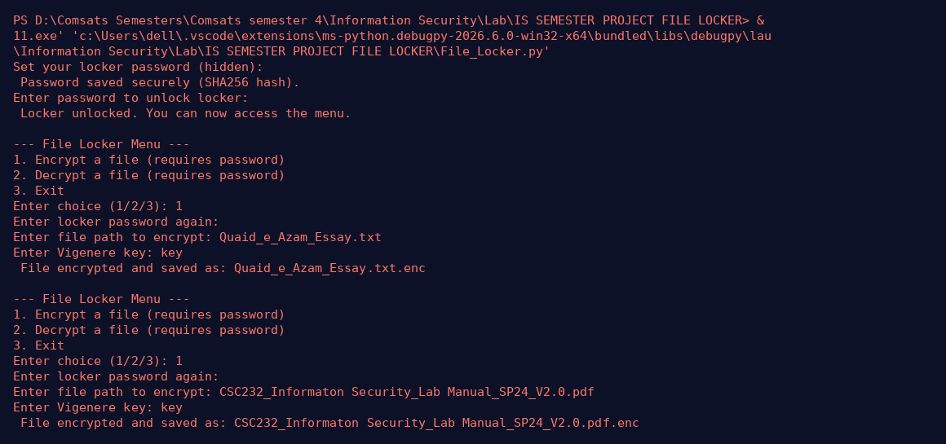
Decryption output
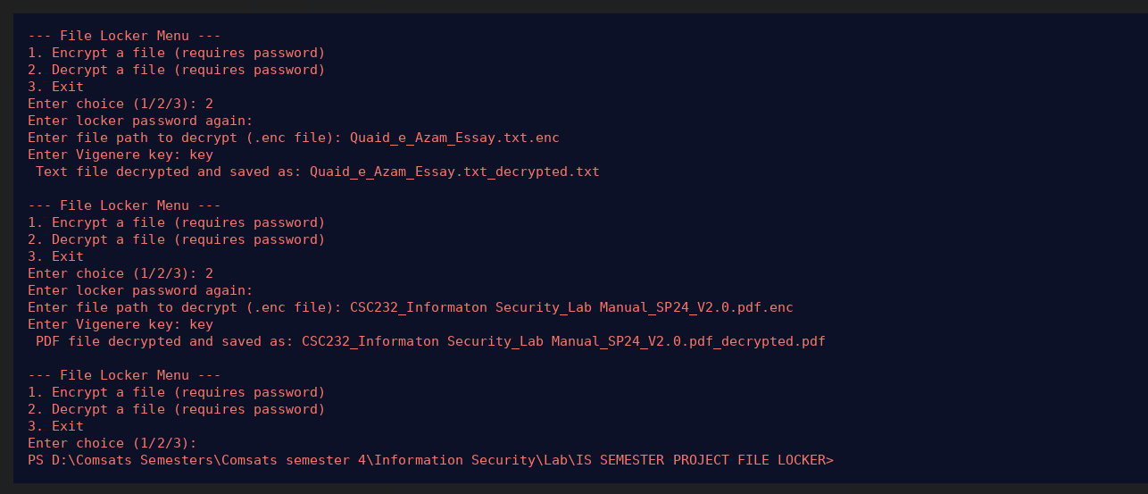

Summary of project
- Shows knowledge of classical cryptography (Vigenère).
- Uses modern security practices (SHA-256 hashing).
- Handles different file types correctly (text vs binary).
- Implements multi-stage password protection.
- Beginner-friendly but demonstrates real security concepts.

